#離斑棉紅蝽

8 posts

[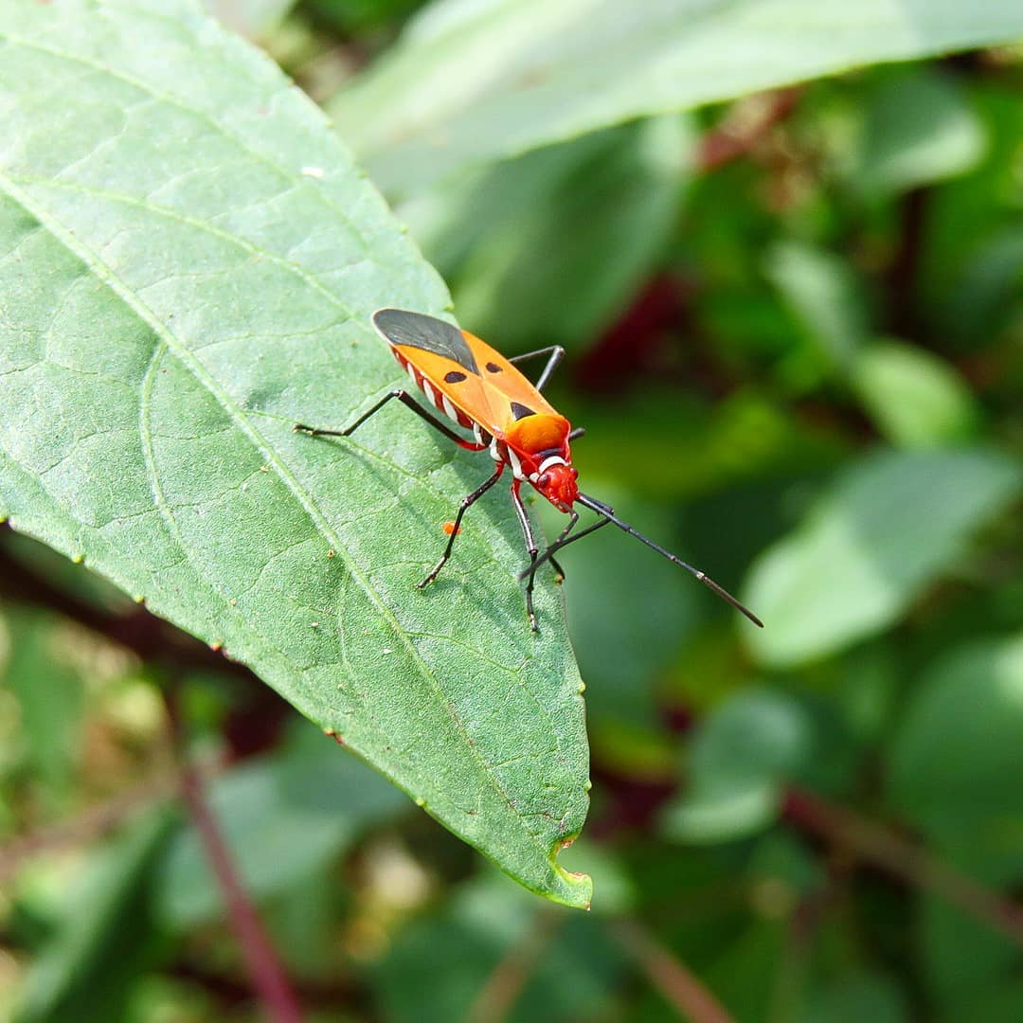](https://deskgram.net/p/1886223917821781552_3859825045)

2018.10.9. ~ [#赤星椿象](https://deskgram.net/explore/tags/%E8%B5%A4%E6%98%9F%E6%A4%BF%E8%B1%A1) ~ 🍃🔶️🕷🔻🍃 [#離斑棉紅蝽](https://deskgram.net/explore/tags/%E9%9B%A2%E6%96%91%E6%A3%89%E7%B4%85%E8%9D%BD) [#椿象](https://deskgram.net/explore/tags/%E6%A4%BF%E8%B1%A1) [#昆蟲](https://deskgram.net/explore/tags/%E6%98%86%E8%9F%B2) [#生態攝影](https://deskgram.net/explore/tags/%E7%94%9F%E6%85%8B%E6%94%9D%E5%BD%B1) [#花草](https://deskgram.net/explore/tags/%E8%8A%B1%E8%8D%89) [#植物](https://deskgram.net/explore/tags/%E6%A4%8D%E7%89%A9) -11 months ago

191 Likes

6 Comments

0

[ㄧ花一天堂
愛情Love
.
不要選擇世界上美麗的人，而是選擇一個能使你的世界美麗的人。
Don’t choose the one who is the beautiful to the world.But rather,choose the one who makes your world beautiful.💕
🍃🍃🍃🍃🍃🍃🍃🍃🍃🍃🍃 🍃🍃🍃🍃🍃
#離斑棉紅蝽 #椿象 #昆虫 #昆蟲 #生物 #昆虫写真 #自然 #ig_insects #dysdercuscingulatus #insects_pics #insect #green #canon #canon_photos #canon_nature #hdr_play_edit #great_myshotz #lovenature #nature_shots #nature_capture #countryroads #canontw攝影分享](https://deskgram.net/p/1873261095680785867_6881853007)

ㄧ花一天堂 愛情Love . 不要選擇世界上美麗的人，而是選擇一個能使你的世界美麗的人。 Don’t choose the one who is the beautiful to the world.But rather,choose the one who makes your world beautiful.💕 🍃🍃🍃🍃🍃🍃🍃🍃🍃🍃🍃 🍃🍃🍃🍃🍃 [#離斑棉紅蝽](https://deskgram.net/explore/tags/%E9%9B%A2%E6%96%91%E6%A3%89%E7%B4%85%E8%9D%BD) [#椿象](https://deskgram.net/explore/tags/%E6%A4%BF%E8%B1%A1) [#昆虫](https://deskgram.net/explore/tags/%E6%98%86%E8%99%AB) [#昆蟲](https://deskgram.net/explore/tags/%E6%98%86%E8%9F%B2) [#生物](https://deskgram.net/explore/tags/%E7%94%9F%E7%89%A9) [#昆虫写真](https://deskgram.net/explore/tags/%E6%98%86%E8%99%AB%E5%86%99%E7%9C%9F) [#自然](https://deskgram.net/explore/tags/%E8%87%AA%E7%84%B6)[#ig\_insects](https://deskgram.net/explore/tags/ig_insects) [#dysdercuscingulatus](https://deskgram.net/explore/tags/dysdercuscingulatus)[#insects\_pics](https://deskgram.net/explore/tags/insects_pics) [#insect](https://deskgram.net/explore/tags/insect) [#green](https://deskgram.net/explore/tags/green) [#canon](https://deskgram.net/explore/tags/canon)[#canon\_photos](https://deskgram.net/explore/tags/canon_photos) [#canon\_nature](https://deskgram.net/explore/tags/canon_nature) [#hdr\_play\_edit](https://deskgram.net/explore/tags/hdr_play_edit)[#great\_myshotz](https://deskgram.net/explore/tags/great_myshotz) [#lovenature](https://deskgram.net/explore/tags/lovenature) [#nature\_shots](https://deskgram.net/explore/tags/nature_shots)[#nature\_capture](https://deskgram.net/explore/tags/nature_capture) [#countryroads](https://deskgram.net/explore/tags/countryroads) [#canontw攝影分享](https://deskgram.net/explore/tags/canontw%E6%94%9D%E5%BD%B1%E5%88%86%E4%BA%AB) - 11 months ago

106 Likes

2 Comments

0

[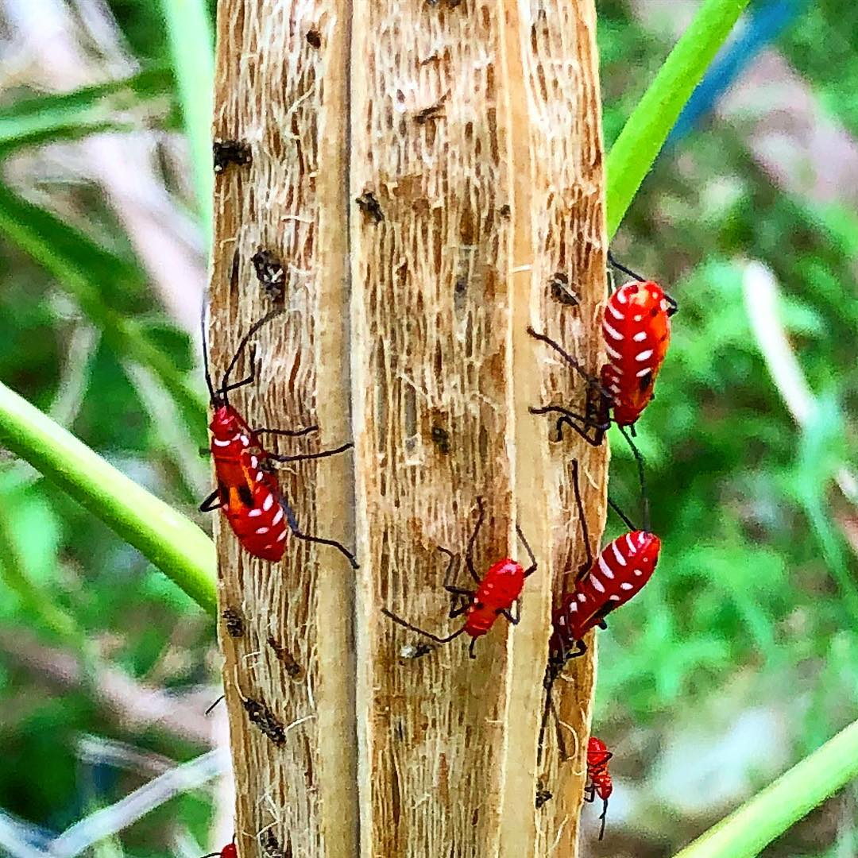](https://deskgram.net/p/1867456163501368198_8420781568)

Stinkbug(Dysdercus cingulatus) eating okra [#insect](https://deskgram.net/explore/tags/insect) [#animals](https://deskgram.net/explore/tags/animals) [#animal\_collection](https://deskgram.net/explore/tags/animal_collection)[#arthropod](https://deskgram.net/explore/tags/arthropod) [#stinkbugs](https://deskgram.net/explore/tags/stinkbugs) [#stinkbug](https://deskgram.net/explore/tags/stinkbug) [#okra](https://deskgram.net/explore/tags/okra) [#椿象](https://deskgram.net/explore/tags/%E6%A4%BF%E8%B1%A1) [#離斑棉紅蝽](https://deskgram.net/explore/tags/%E9%9B%A2%E6%96%91%E6%A3%89%E7%B4%85%E8%9D%BD) - 11 months ago

19 Likes

0 Comments

0

[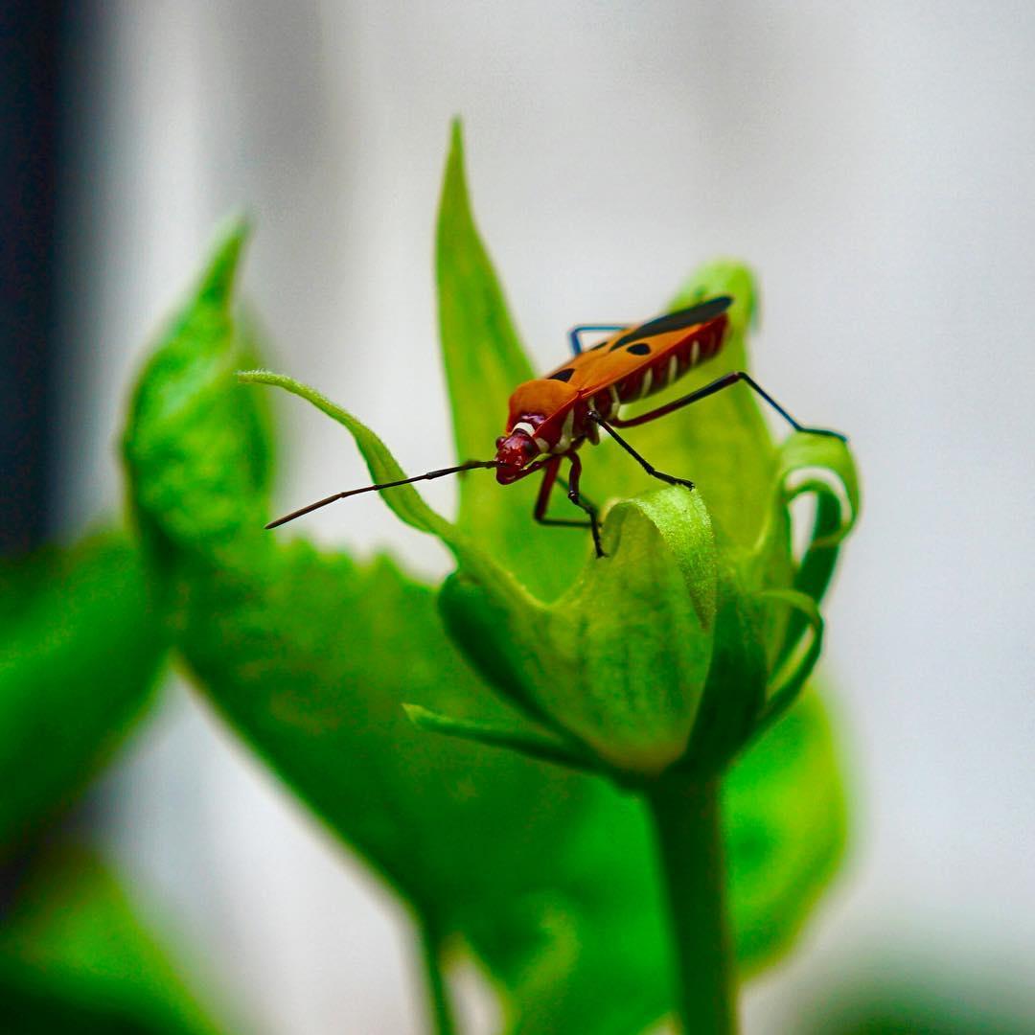](https://deskgram.net/p/1833384194367851325_5853305658)

[#離斑棉紅蝽](https://deskgram.net/explore/tags/%E9%9B%A2%E6%96%91%E6%A3%89%E7%B4%85%E8%9D%BD) [#dysdercuscingulatus](https://deskgram.net/explore/tags/dysdercuscingulatus) [#2](https://deskgram.net/explore/tags/2) - 1 year ago

21 Likes

0 Comments

0

[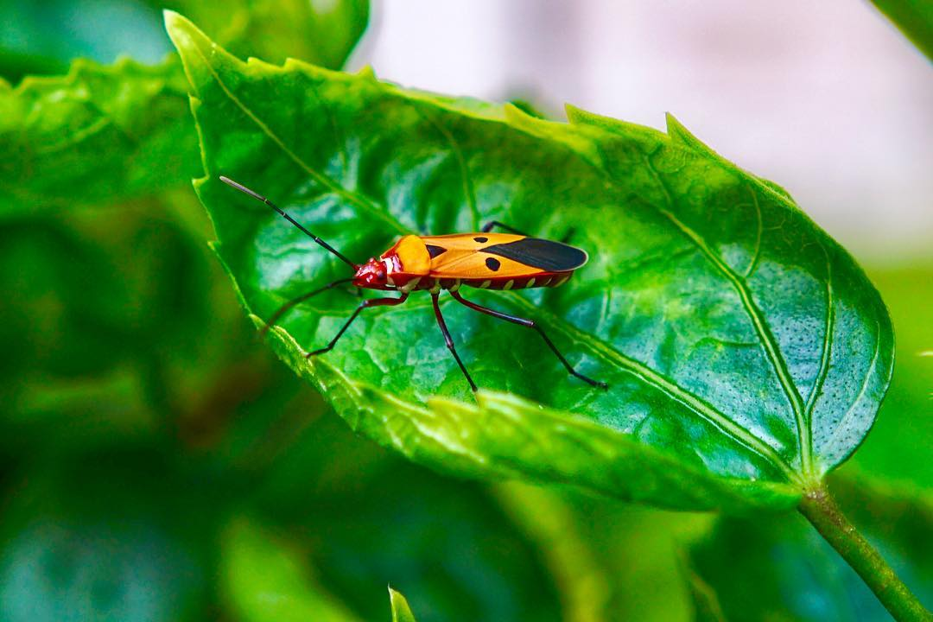](https://deskgram.net/p/1833383932400052926_5853305658)

[#離斑棉紅蝽](https://deskgram.net/explore/tags/%E9%9B%A2%E6%96%91%E6%A3%89%E7%B4%85%E8%9D%BD) [#dysdercuscingulatus](https://deskgram.net/explore/tags/dysdercuscingulatus) [#1](https://deskgram.net/explore/tags/1) - 1 year ago

12 Likes

0 Comments

0

[#離斑棉紅蝽 #赤星蝽象 
Dysdercus cingulatus
#Dysdercuscingulatus
#dysdercus

Category : #meowmeow_insect
Category : #meowmeow_紅蝽](https://deskgram.net/p/1829188836388231096_6210480638)

[#離斑棉紅蝽](https://deskgram.net/explore/tags/%E9%9B%A2%E6%96%91%E6%A3%89%E7%B4%85%E8%9D%BD) [#赤星蝽象](https://deskgram.net/explore/tags/%E8%B5%A4%E6%98%9F%E8%9D%BD%E8%B1%A1) Dysdercus cingulatus[#Dysdercuscingulatus](https://deskgram.net/explore/tags/Dysdercuscingulatus) [#dysdercus](https://deskgram.net/explore/tags/dysdercus) Category : [#meowmeow\_insect](https://deskgram.net/explore/tags/meowmeow_insect) Category : [#meowmeow\_紅蝽](https://deskgram.net/explore/tags/meowmeow_%E7%B4%85%E8%9D%BD) - 1 year ago

16 Likes

0 Comments

0

[#離斑棉紅蝽 #赤星蝽象 若蟲
Dysdercus cingulatus
#Dysdercuscingulatus
#dysdercus

Category : #meowmeow_insect
Category : #meowmeow_紅蝽](https://deskgram.net/p/1812309625301446217_6210480638)

[#離斑棉紅蝽](https://deskgram.net/explore/tags/%E9%9B%A2%E6%96%91%E6%A3%89%E7%B4%85%E8%9D%BD) [#赤星蝽象](https://deskgram.net/explore/tags/%E8%B5%A4%E6%98%9F%E8%9D%BD%E8%B1%A1) 若蟲 Dysdercus cingulatus [#Dysdercuscingulatus](https://deskgram.net/explore/tags/Dysdercuscingulatus) [#dysdercus](https://deskgram.net/explore/tags/dysdercus)Category : [#meowmeow\_insect](https://deskgram.net/explore/tags/meowmeow_insect) Category : [#meowmeow\_紅蝽](https://deskgram.net/explore/tags/meowmeow_%E7%B4%85%E8%9D%BD) - 1 year ago

16 Likes

0 Comments

0

[離斑棉紅蝽
#離斑棉紅蝽 #椿象 #蝽 #昆蟲 #臭屁蟲 
#hemiptera #pyrrhocoridae 
#insectagram #insect #insects 
#tgif_insects #kings_insects #ig_insects #ip_insects #ip_connect #bns_buginsects #garden_explorers](https://deskgram.net/p/1545728964072652012_279253948)

離斑棉紅蝽 [#離斑棉紅蝽](https://deskgram.net/explore/tags/%E9%9B%A2%E6%96%91%E6%A3%89%E7%B4%85%E8%9D%BD) [#椿象](https://deskgram.net/explore/tags/%E6%A4%BF%E8%B1%A1) [#蝽](https://deskgram.net/explore/tags/%E8%9D%BD) [#昆蟲](https://deskgram.net/explore/tags/%E6%98%86%E8%9F%B2) [#臭屁蟲](https://deskgram.net/explore/tags/%E8%87%AD%E5%B1%81%E8%9F%B2) [#hemiptera](https://deskgram.net/explore/tags/hemiptera) [#pyrrhocoridae](https://deskgram.net/explore/tags/pyrrhocoridae) [#insectagram](https://deskgram.net/explore/tags/insectagram)[#insect](https://deskgram.net/explore/tags/insect) [#insects](https://deskgram.net/explore/tags/insects) [#tgif\_insects](https://deskgram.net/explore/tags/tgif_insects) [#kings\_insects](https://deskgram.net/explore/tags/kings_insects)[#ig\_insects](https://deskgram.net/explore/tags/ig_insects) [#ip\_insects](https://deskgram.net/explore/tags/ip_insects) [#ip\_connect](https://deskgram.net/explore/tags/ip_connect)[#bns\_buginsects](https://deskgram.net/explore/tags/bns_buginsects) [#garden\_explorers](https://deskgram.net/explore/tags/garden_explorers) - 2 years ago

45 Likes

2 Comments

0

